Run 4 the Rock Foghorn VIRTUAL Race Plan
West Douglas Pioneer Rd, Course will be well marked!
ANYTIME YOU CHOOSE between Sunday, April 12th and Saturday, April 18, 2020

Eldred Rock Lighthouse Association will mark the Start Line, the 2K finish line, and the 5K and 10K turn around points. The 5K and 10K are out and back, so the start line and finish line are the same. There will be no race equipment and no course officials on Pioneer Road for this Virtual Race, but temporary signs and markings will be out. Racers are expected to start and stop their own watches or phones and submit their time to the race coordinator. A photo of the time is even better! The HONOR SYSTEM and SOCIAL DISTANCING is expected. The race is an open course with no motorized vehicles permitted. Since everyone will be running on their own, there should be no big groups and dogs are permitted on Pioneer Road

The 2K Hillclimb will begin at the startline and end at the top where the first “stump cut” bench is located. There will be NO course officials at that finish line.
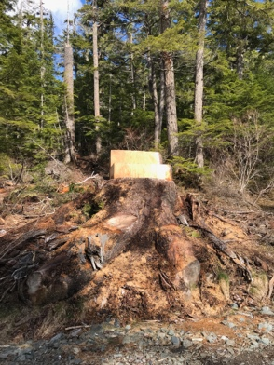
The 5K will begin/end at the start with a turnaround at 1.55 M just before the bridge. There will be a sign and marking at the turnaround.
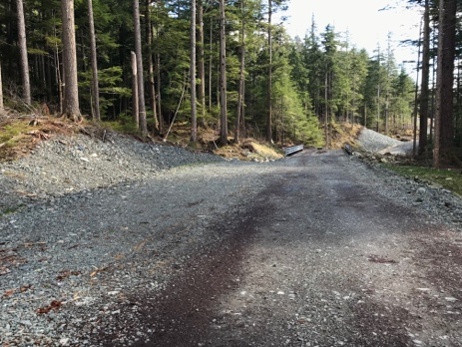
The 10K will begin/end at the start with a turnaround at 3.1M, exactly .4 miles from the end of Pioneer Rd. There will be a sign and marking at the turnaround.

