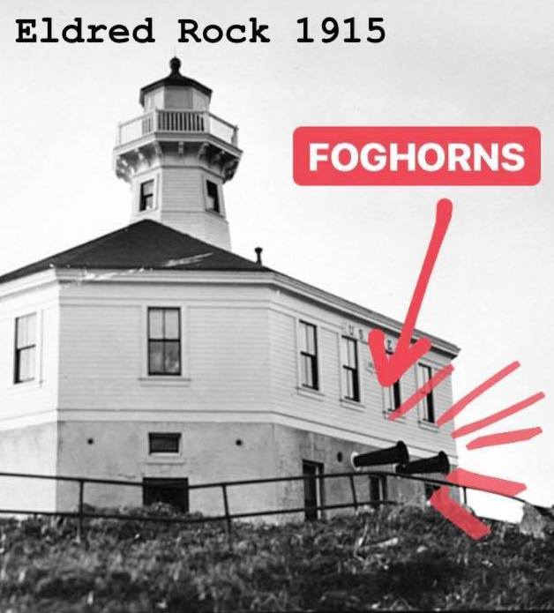 Register ONLINE by emailing form to slyak3@yahoo.com or texting photo of form to (907) 255-3662. Pay at www.paypal.me/eldredrocklighthouse
“Fog Horn Virtual Race”
Run 2K, 5K or 10K course on your own, send in time
Pioneer Road (End of North Douglas Hwy)

Virtual Race
Run 4 the ROCK

Anytime between April 12-18th

**The 2K Hillclimb, or 5K/10K out and back course will be marked; time yourself and submit time via email or text. THIS VIRTUAL RACE is via the Honor System!
Entry for any day between April 12-18th: Adults: $15, Students $5, Under 5 Free
Membership Entry Fee: $25 *Includes membership to ERLPA
A fundraiser hosted by the Eldred Rock Lighthouse Preservation Association
www.eldredrocklighthouse.org www.facebook.com/EldredRockLighthouse

